Deployment Diagram:

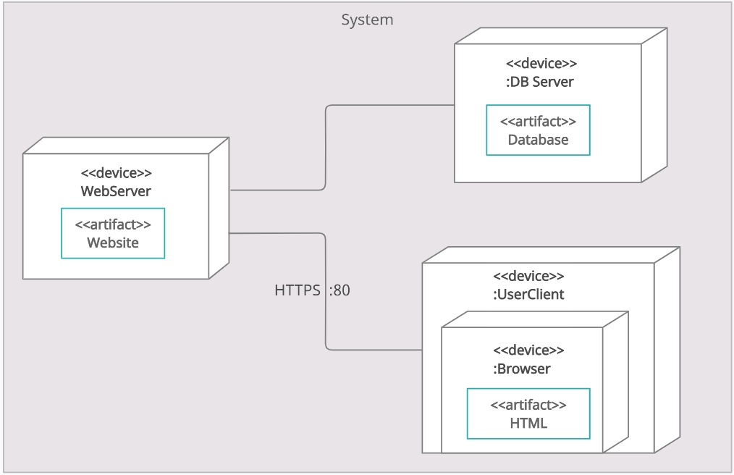

Java script libraries which we have discussed to use in building our web application:

1. JQuery: This library is designed to simplify HTML DOM tree traversal and manipulation, as well as event handling, CSS animation, and Ajax.
2. JQuery UI: This library is for GUI widgets, animated visual effects, and themes implemented with jQuery (a JavaScript library), Cascading Style Sheets, and HTML.
3. React: JavaScript library for building user interfaces or UI components
4. Debug: to debug java script application in both browser and node.js.
5. Socket.IO: This library is used for real time web applications.